NORTH INDIA SURGICALS

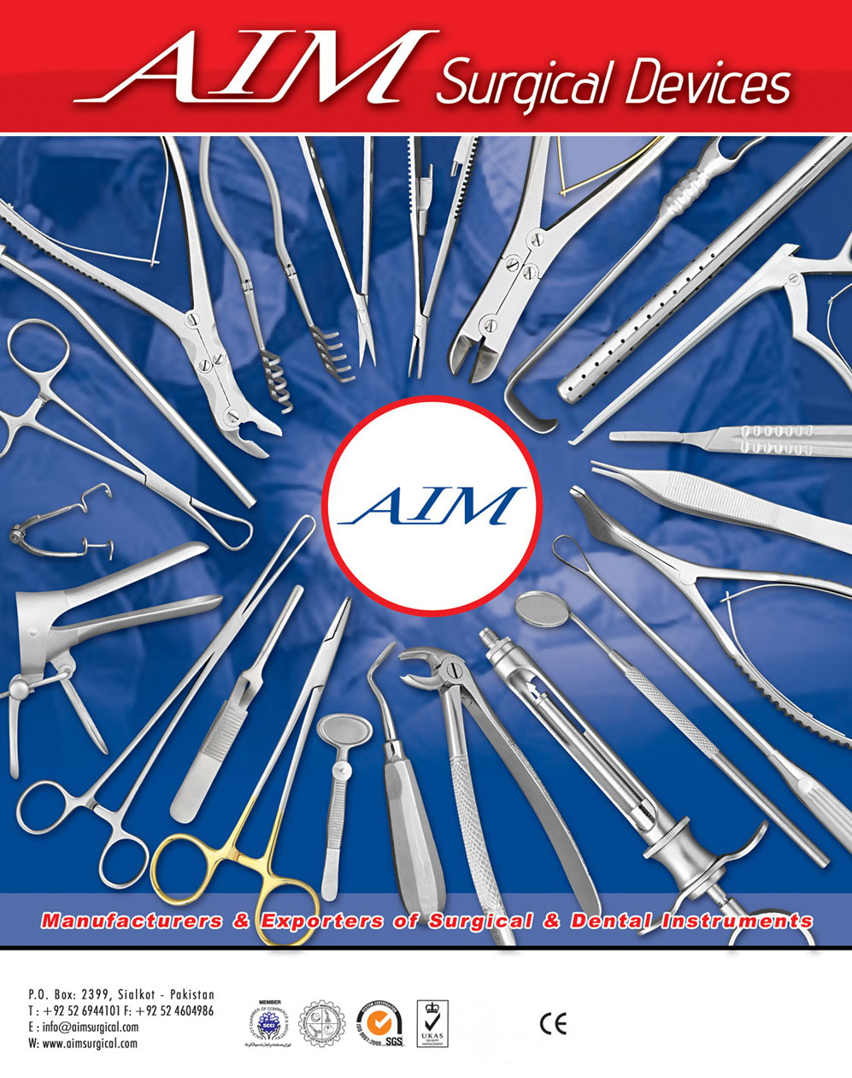

DEALING IN :- ALL KINDS OF SURGICALS INSTRUMENTS AND HOSPITAL EQUIPMENTS

Email:–northindiasurgicals@gmail.com Mobile No:- 9810348909 / 981889935
H.O. Block- A - 161/1, Majlis Park, Adarsh Nagar Delhi - 110033
B.O. Shop No. 51,L.S.C.DDA,Mkt.Pkt-B,Phase-III,AshokVihar,Delhi-110052

